Operating Systems Project – PHASE 2 Report

INTRODUCTION
File Transfer Protocol (FTP) is a standard network protocol used to transfer files between a client and a server over a network. In this task, an FTP server was configured on one Ubuntu virtual machine using vsftpd, and the second Ubuntu machine was used as an FTP client to test connectivity and file transfer.

IMPLEMENTATION
Role Assignment
- Ubuntu 1 → FTP Server
- Ubuntu 2 → FTP Client
Step 1 – Updating the Package Repository
Update the list of available software packages from Ubuntu repositories. It ensures that the latest versions of packages are installed.
sudo apt update
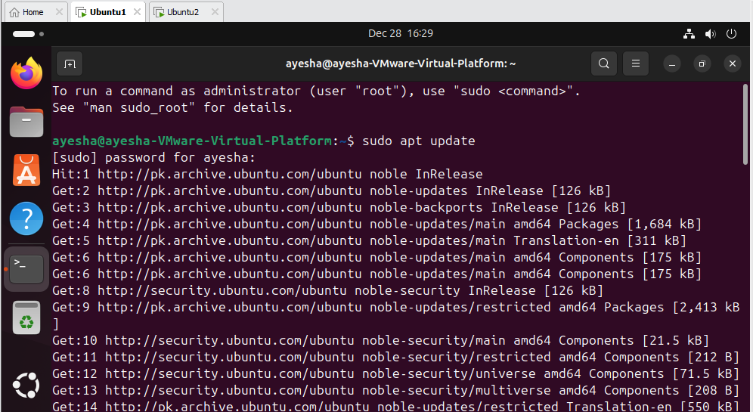
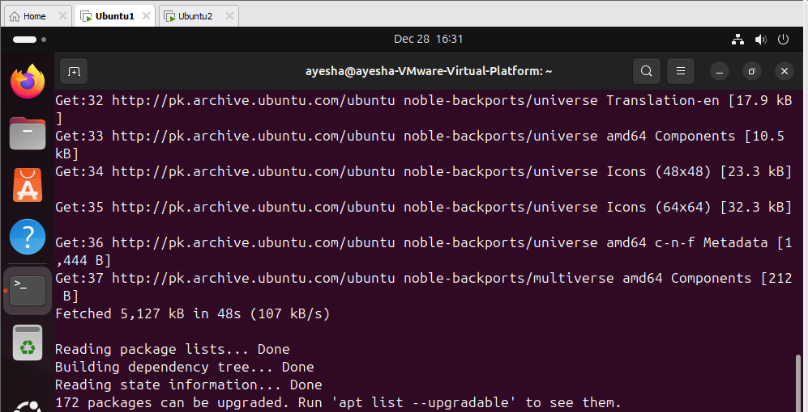
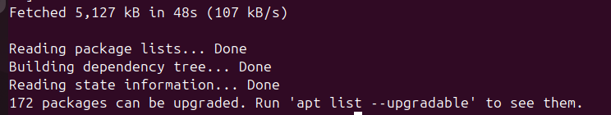

Step 2 – Installing the FTP Server (vsftpd)
Install vsftpd (Very Secure FTP Daemon), which is a lightweight and secure FTP server used in Linux systems. The -y flag automatically confirms installation.
sudo apt install vsftpd -y
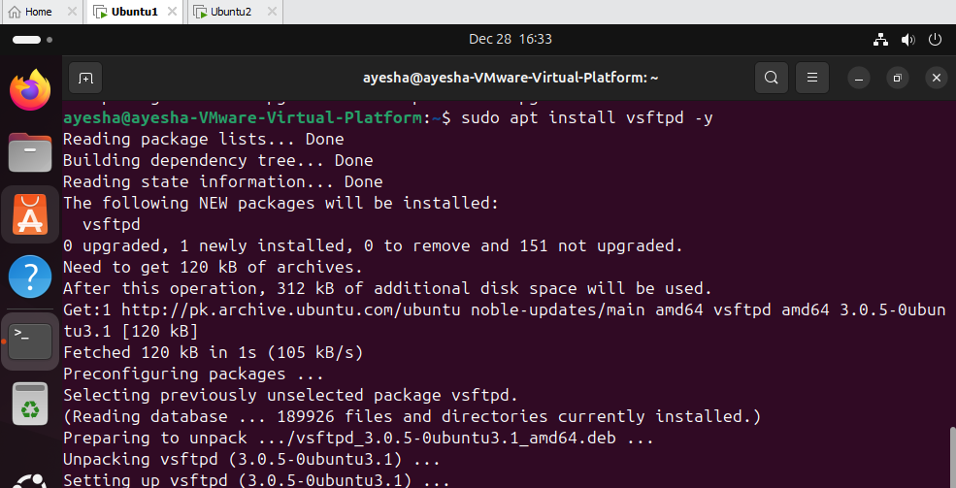
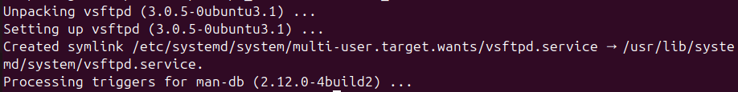

Step 3 – Starting and Enabling FTP Service
sudo systemctl start vsftpd
sudo systemctl enable vsftpd
sudo systemctl status vsftpd

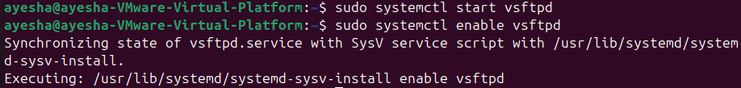
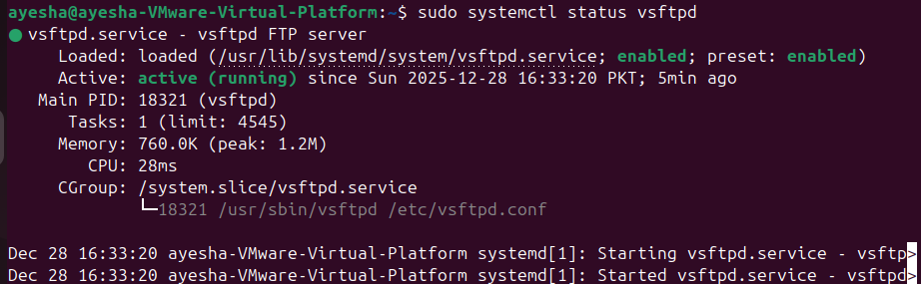
Explanation:
- start → Starts the FTP service immediately
- enable → Ensures the FTP service starts automatically on system boot
- status → Displays the current status of the FTP service to confirm it is running
Step 4 – Allowing FTP Through Firewall
sudo ufw allow 20/tcp
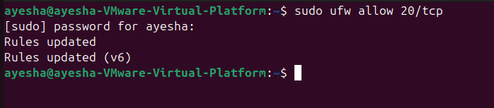

sudo ufw allow 21/tcp
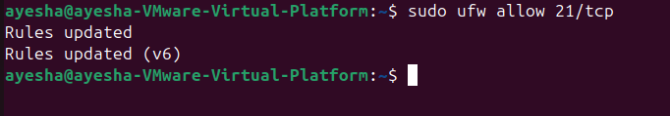
sudo ufw reload

Explanation:
FTP uses port 21 for control and port 20 for data transfer. These commands allow FTP traffic through the firewall and reload firewall rules.

Step 5 – Configuring the FTP Server
sudo nano /etc/vsftpd.conf
Explanation:
Open the main configuration file of vsftpd for editing.
The following configuration options were enabled:
local_enable=YES
write_enable=YES
chroot_local_user=YES
allow_writeable_chroot=YES
Purpose of each setting:
- local_enable=YES → Allows local system users to log in via FTP
- write_enable=YES → Allows uploading and modifying files
- chroot_local_user=YES → Restricts users to their home directory for security
- allow_writeable_chroot=YES → Resolves writable directory restriction error
Step 6 – Restarting FTP Service
Restart the FTP service to apply configuration changes.
sudo systemctl restart vsftpd

Step 7 – Creating an FTP User
Create a new user account named ftpuser. Use this account for FTP login and file transfers.
sudo adduser ftpuser
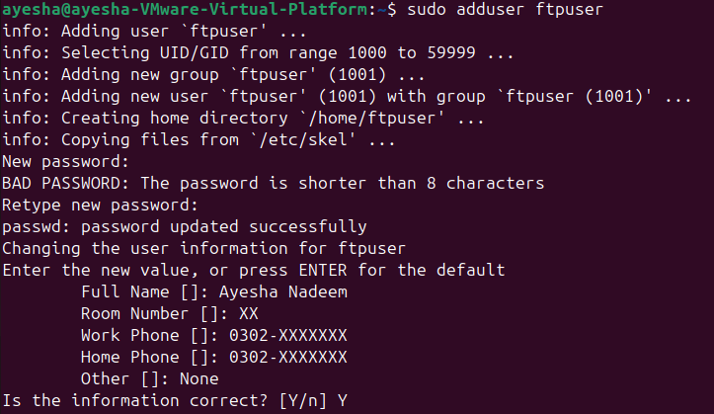
Step 8 – Creating a Test File (Client Side)
echo "hello ftp" > testfile.txt
Create a test file named test.txt with sample content to verify file upload functionality.
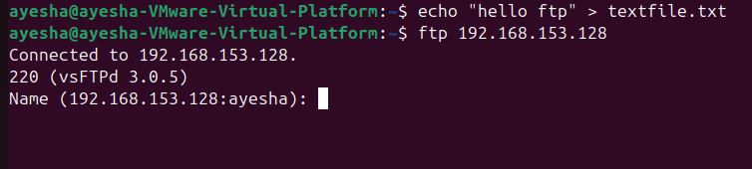
Step 9 – Connecting to FTP Server from Client
ftp 192.168.153.128
Connect the FTP client (Ubuntu 2) to the FTP server (Ubuntu 1) using the server’s IP address.

Step 10 – Authenticating FTP User
Name: ftpuser
Password: ayesha2005
The FTP client authenticates using the previously created FTP user credentials. Successful authentication confirms that the FTP server is working.
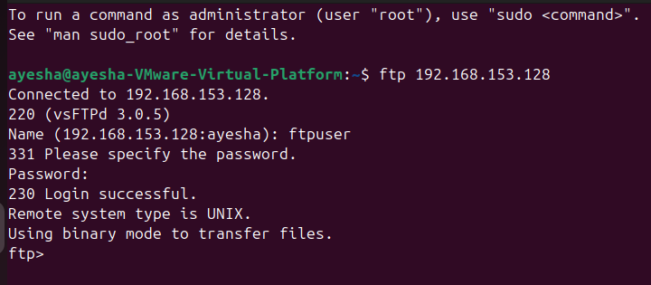

Step 11 – Uploading File to FTP Server
put testfile.txt
The put command uploads the test file from the client system to the FTP server. Successful upload confirms proper FTP configuration.
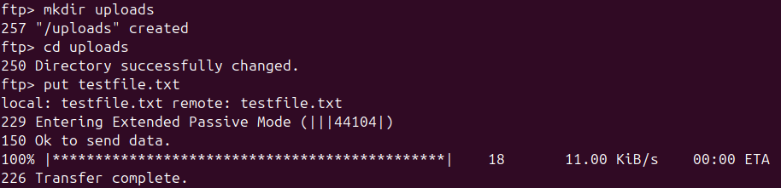

CONCLUSION
In this task, an FTP server was successfully configured using vsftpd on Ubuntu. A client machine connected to the server, authenticated using a local user account, and transferred files successfully. This demonstrates correct server configuration and network communication between the virtual machines.

